


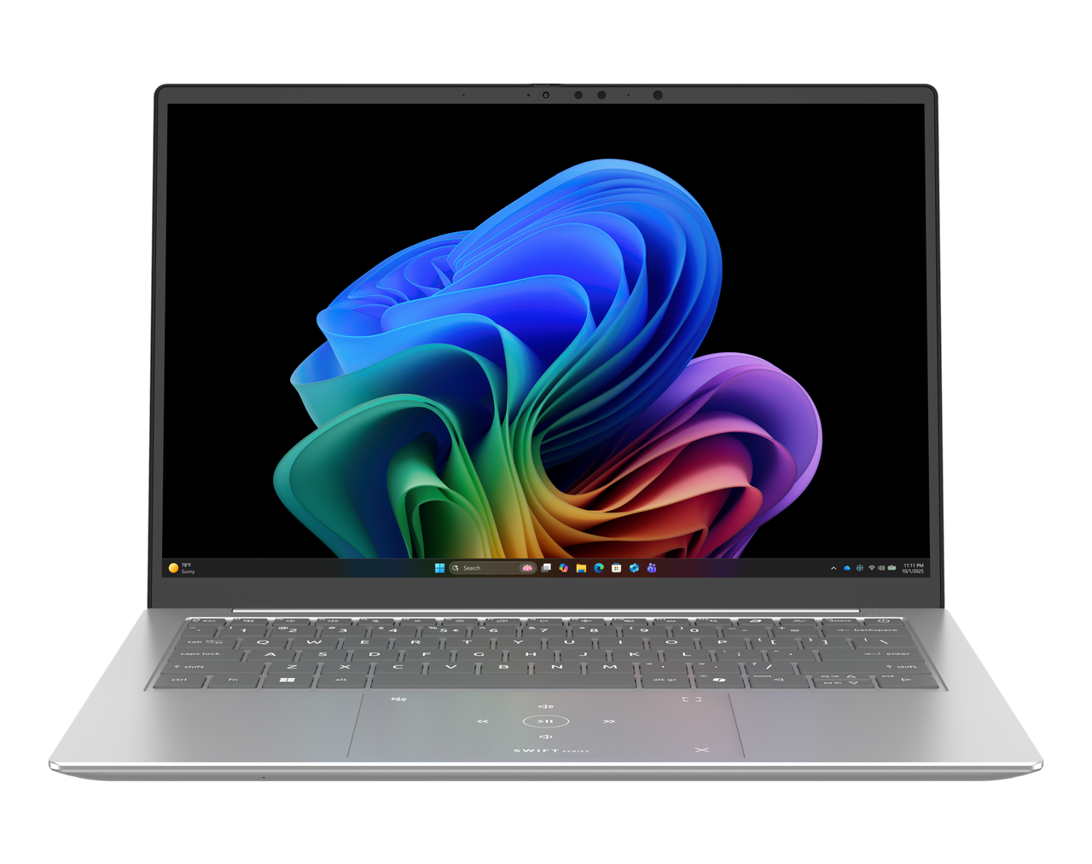

Swift Edge 14 AI
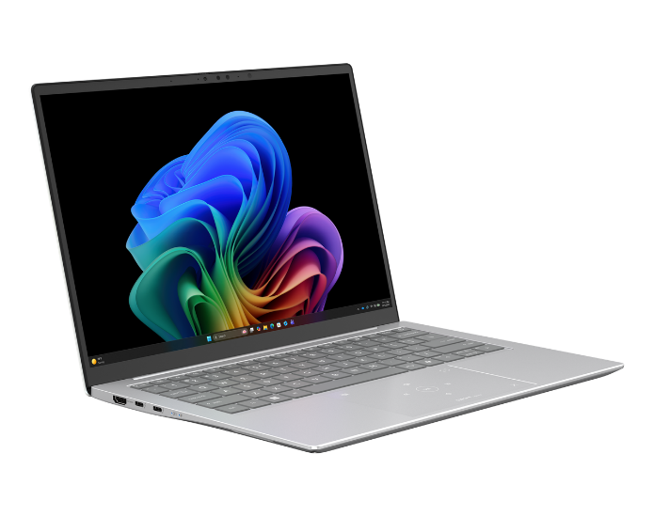
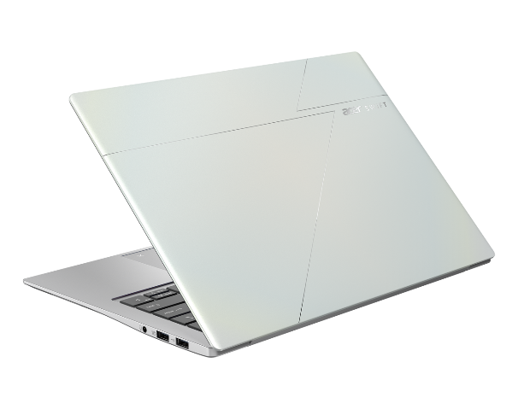
SPECIFICATIONS Swift Edge 14 AI SFE14-I51
1
3
2
10
4

9
Product views | - Microphones  - Camera  - IR Camera / IR LED with Shutter  - 14.0" display  - HDMI port | - Thunderbolt™ 4 port  - Thunderbolt™ 4 port  - Multi-control Touchpad  - Copilot Key  - Power button |  |  | - Audio Jack  - USB 3.2 port  - USB 3.2 port
Operating system¹ | Windows 11 Home
CPU and chipset¹ | Intel® Core™ Ultra 5 processor 325 | Intel® Core™ Ultra 7 processor 355 |  |  | Intel® Core™ Ultra 9 processor 386H
Memory^{1, 2, 3} | Dual-channel LPDDR5X SDRAM support  - 16/24/32 GB of onboard LPDDR5X system memory |  |  | Memory Frequency : Up to 7467 MT/s
Display⁴ | 14.0" display with OLED (Organic Light-Emitting Diode) technology, WUXGA 1920 x 1200, high-brightness (400 nits, typical value) Acer CineCrystal™  - 16:10 aspect ratio, color gamut DCI-P3 100%(Typical value)  - Wide viewing angle up to 170 degrees"  - Mercury free, environment friendly  14.0" display with OLED (Organic Light-Emitting Diode) technology, WQXGA+ 2880 x 1800, high-brightness (400 nits) Acer CineCrystal™  - 16:10 aspect ratio, color gamut DCI-P3 100%, certified by True Black HDR 500(@HDR 500, brightness reach 500 nits)"  - Wide viewing angle up to 170 degrees"  - Mercury free, environment friendly"
Graphics¹ | Intel® Graphics eligible |  |  | Intel® ARC™ Graphics 130V
Audio | - DTS® X:Ultra Audio, featuring optimized Bass, Loudness, Speaker Protection with up to 3 custom content modes via smart amplifier  - Smart Auto switch to Voice enhanced Mode via VOIP  - High SNR DAC with 2.1 Vrms out capability and can driver high impedance headphone (up to 600 ohm)  - Acer Purified Voice technology with AI noise reduction in 3 mics array built-in microphones to support Advanced Privacy Mode. Features include far-field pickup, dynamic noise reduction through neural network, adaptive beam forming, and pre-defined personal and conference call modes.  - Acer Ultra Boost Stereo Speaker Module &PCR 50% material chamber design  - Compatible with Cortana with Voice  - Acer TrueHarmony Technology for lower distortion, wider frequency range, headphone-like audio and powerful sound  - Hi-Res Audio Certification by JAS ( Headphone Output setting supported up to 24bit /192KHz)
Storage^{1, 6} | Solid state drive  - 512 GB / 1 TB, PCIe Gen4, 16 Gb/s, NVMe
Webcam¹ | Video conferencing  - UFC with:  - Narrow USB FHD camera+IR camera with blue glass  - Compatible with Windows only  - 1920 x 1080 resolution  - 1080p video fps with Temporal Noise Reduction  - Blue glass lens |  | - Staggered High Dynamic Range (SHDR)  - Dual Mic (33 mm + 33 mm)  - 88 x 3.2 x 2.6 mm
Wireless and networking¹ | WLAN  - Multi-Link Operation 802.11 a/b/g/n/ac/ax/be  - Killer™ Wi-Fi 7 Wireless LAN  - 802.11 a/b/g/n/ac/ax/be  - Band: 2.4 GHz, 5 GHz, and 6 GHz  - 2x2 MU-MIMO technology | WPAN  - Supports Bluetooth® 5.4 or above
Security | MSFT Pluton Security Processor as Firmware TPM solution
Dimensions and weight^{7,8} | Dimensions: •315.2 (W) x 218.6 (D) x 7.4/13.9 (H) mm (12.41 x 8.61 x 0.29/0.55 inches)  Weight: •0.99 kg (2.18 lbs.) with 3-cell battery pack, WQXGA display
Power adapter and battery^{9,10} | Power adapter  100W PD Adapter for Fast Charging
Input and control | Acer Backlight Keyboard (81/82 UI/UK Key Layout) – SR03P  With multiple international language support  - Slim design with 1.3 mm travel distance  - AcerSense app enabling  - AI function activation indicator (on Copilot)  - Enlarged keycaps for better typing feel  - Optimal backlight brightness for better legibility  - Quiet and silent design for noise reduction  - Titanium metal frame support  - Caps Lock and microphone mute toggle indicators  - Function lock for user hotkey preference | Touchpad  - Multi-gesture Lighting touchpad, supporting two-finger scroll; pinch; gestures to open Cortana, Action Center, multitasking; application commands  - Multi-control Lighting touchpad  - Microsoft Precision Touchpad certification"  - Moisture resistant  - Corning® Gorilla® Glass |  |  | Control Keys  - Acer Sense Key  - Copilot Key  - Programmable key – my key
Windows Desktop Apps¹² | In-House  - Acer AI Image Generator  - Acer LiveArt  - Acer ORD Service  - Acer QuickPanel  - Acer VisionArt | Search  - AcerSense |  |  | Tools  - Acer My Key Application
Warranty | One-year International Travelers Warranty (ITW)
- Specifications vary depending on model.
- Shared system memory may be allocated to support graphics, depending on system memory size and other factors. Actual system memory available to the operating system will be reduced by any memory used by the graphics solution and resources required by the operating environment.
- Memory speed may vary, depending on the CPU, chipset or memory fitted.
- All brands and product names mentioned herein include trademarks of their respective companies and are used solely to describe or identify the products.
- Not all features indicated are supported on all SKUs
- 1 GB is 1 billion bytes. Actual formatted capacity is less and may vary depending on preloaded materials and operating environment. Acer Recovery Management uses a portion of the stated hard disk capacity as dedicated backup space.
- Minor variations in system dimensions are possible due to the manufacturing process.
- Weight may vary depending on product configuration, vendor components, manufacturing variability, and selected options.
- Listed battery life is based on testing using video playback. The test clip loops and continues to run, without interruption or any other inputs, until the battery is drained. Stated battery life is for comparison purpose only. Actual battery life varies by model, configuration, applications, video chip format and features used. A battery's maximum capacity decreases with time and use. Battery life test configuration: Intel® ULTRA 9 (Series 3), Intel® Graphics, WQXGA+ OLED, SSD only, 32GB of LPDDR5X memory. Battery life test condition: LCD brightness 150 nits, connected headphones, WLAN off, Bluetooth off and Better Battery Mode on.
- Listed battery life is based on testing using Web browsing. The test clip loops the loading of 50 selected websites using Microsoft Edge every 30 seconds, until the battery is drained. Stated battery life is for comparison purpose only. Actual battery life varies by model, configuration, applications, video chip format and features used. A battery's maximum capacity decreases with time and use. Battery life test configuration: Intel® ULTRA 9 (Series 3), Intel® Graphics, WQXGA+ OLED, SSD only, 32GB of LPDDR5X memory. Battery life test condition: 100 nits LCD brightness, 50% speaker volume, WLAN on, Bluetooth on, no WW direct Internet connection.
- Actual battery life may vary considerably by specifications, depending on product model, configuration, applications, power management settings, operating conditions, and features utilized. Performance variation also arises based on components in use, which includes but is not limited to the processor, RAM capacity, storage, display and resolution, etc.
- Bundled software may vary depending on hardware configuration, OS and regional availability.
Note: This specification is based on Swift SFE14-I51 (Win11) Specifications (v2-0-1) (Preview)
13
11
12
8
7
6
5

